Assignment #4

MDEV1005

**Planning:** Referred to the Assignment #4 PowerPoint slides under Blackboard shell, and some flutter tutorials.

**Implementation:**

**Widget used:**

Weather widget – to show weather details on the app screen

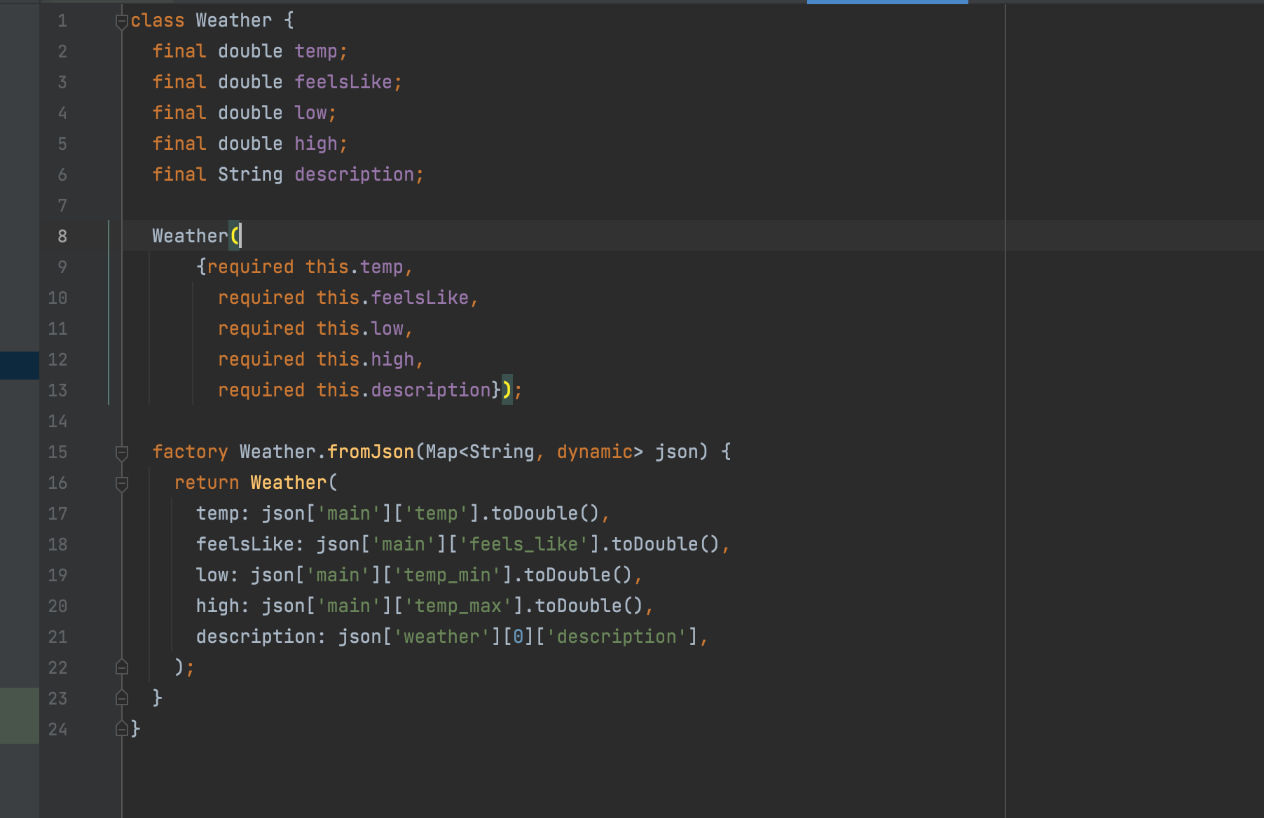

**API used:**

**Roadblocks:**

Setting up flutter and getting free API’s was kind of difficult for me

Reference: https://github.com/backslashflutter/email_password_flutter_firebase